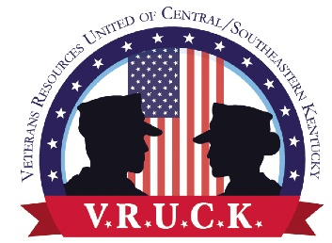
WEEK OF VALOR
EVENT REGISTRATION
BOOTH/SPACE REGISTRATION
NOVEMBER 5 AND 6, 2021
Location: Masterson Station, 3051 Leestown Road, Lexington, Ky
Organization’s Name: _______________________________________________
Address: Street: ____________________________________________________
City: _______________________ State: __________ Zip Code: _____________
Telephone: _____________ Email: ____________________________________
Contact Person: ____________________________________________________
Bringing a Tent: _______ If so, Size: __________________________________
Do you need access to electricity: ______________________________________
Participating: November 5: ______ November 6: ______ Both Days:_________
Other than a tent, what will you be providing? ____________________________
Any special accommodations needed: ___________________________________
What Product or Service will your organization by providing? ________________
____________________________________________________________________
*No sales of any products will be allowed
For additional information, please contact Phyllis Abbott at (859) 806-4297 or via email at info@ladyveteransconnect.org
Thank you for partnering with VRUCK in serving our military, service members, and families!

